Specification sheet:

**Greeting card:**

This is a simple greeting cards implementation. This greeting card plays a tone for a minimum of 15 seconds, combining multiple notes together. The buzzer acts as feedback to the user when they press a button. In total there are two timers that control two different melodies that play together to produce a song. The greeting card stays on, until a button press is detected. The default package comes in with a pink panther starter theme song, with two different octaves.

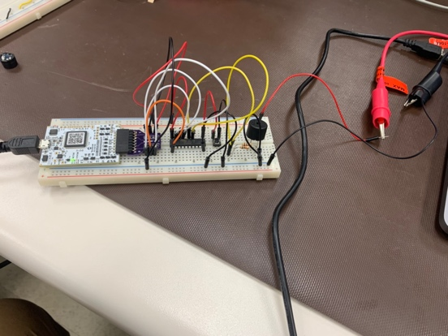

To operate the device:

You need to power it up with a power supply, set to 5 volts and 0.1 Amps to the red and black jumper in figure 1. Ensure the array music1 and music2 are filled in with the different frequencies for the music and the size of the array match its number of contents. To calculate the different frequencies for various notes, use:

Figure 1: Prototype picture

$$f_{OCnx }=\frac{f_{clk _ I/0 }}{2*N*\left(1+OCRnA\right)}$$

Where, N is the clock pre scale, $f_{OCnx }$ are the frequencies for the different notes, $f_{clk _ I/0 }$ is the CPU clock speed MHz, and OCRnA is the frequency we need to input in the music1 and 2 arrays. Certain Octaves are defined as constants in the file.

After this, run the code and press the button in which the system will take the input from 0 -> 1

Testing: The device was tested with a sample song. The sample song selected was from the pink panther start up song. The 8bit and 16bit timers were both tested to produce the music (the 16-bit timer played the song at a higher octave) and it was successful. Upon the press of the button both the timers started, and once the button was let go, it finished the cycle and turned off.

Operating conditions:

|  |  |
| --- | --- |
| Temperature range (ATTiny2313A) | -40°C to +85°C |
| Voltage rating | 1.8 – 5.5 (volts) |
| Ready time | 30 seconds – 120 seconds |
| Nominal weight | 100 grams |
| Piezo buzzer (Temp) | -10°C to +70°C |

**Warning: To avoid damage to the unit keep these points in mind**

1. Do not use this unit in the environment of rain
2. Do not leave unit near high temperatures
3. Do hold the unit from the loops of the jumper cables

**System requirements:**

* MPLAB x software installed – Support for the following OS: Windows 7, Mac OS X 10,11 or higher, Windows 10, Linux 18.04 or higher
* USB 2.0/ USB3.0 for connection to the device
* Power supply/ Analogue discovery, supplying power at 5 volts and 0.1A
* Intel core i5, 10GB hard disk space and 4GB ram